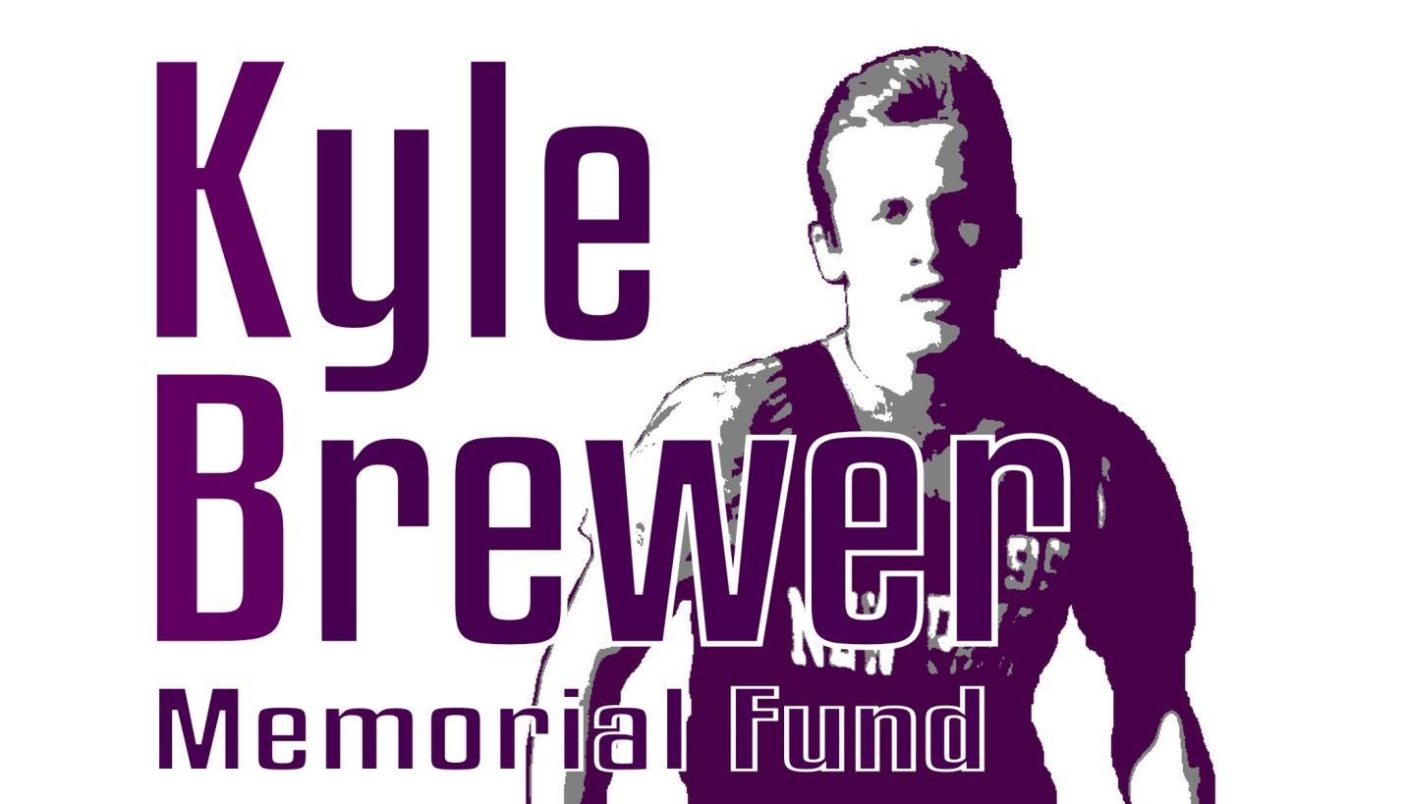
Bowl-A-Thon Fundraiser
Sponsorships

Dear Sir or Madam,

The Kyle Brewer Memorial Fund, a 501 (c) (3), non-profit foundation, is seeking sponsorships for our 3rd Annual
Bowl-a-Thon fundraiser. Perhaps you would like to be a Platinum Sponsor ($500) or Gold Sponsor ($250) or Silver Sponsor ($100)!! The Platinum Sponsors will have their logo printed on the Bowl-a-Thon T-Shirt and includes two bowlers. The Gold Sponsors will have their name in bold lettering on the T-shirt. Silver sponsors will have their name in fine print on the T-shirt. We are hoping that your business will consider contributing to our event! As a 501 (c) (3), please note that any donations made are completely tax deductible. Our Employer Identification Number is:
81-4859890.

The event will be held on May 11, 2019 from 1:00 – 4:00 pm at Tarsio Lanes in Newburgh and will include a Tricky Tray Raffle, a “make your own Sundae” station, special T-shirts and prizes for bowlers.
Tickets cost $20 and include 3 hours of bowling, shoe rental, an ice cream sundae and a Kyle Brewer Memorial Fund Bowl-a-Thon T-shirt. If you would like to support the Fund, but are not a bowler, “Spectator Tickets” cost $10 and include an ice cream sundae and 5 Tricky Tray raffle tickets.

The Kyle Brewer Memorial Fund was established in the memory of Kyle Brewer who passed away on March 15, 2015 at the age of 16 caused by sudden cardiac arrest due to an undetected congenital heart defect. This third Bowl-A-Thon will maintain the Fund and use the proceeds to provide community outreach programs related to sudden cardiac arrest in children and youth and scholarships to members of the graduating class at New Paltz High School. The Memorial Fund will continue to accept contributions so the scholarships and other community outreach can continue for many years in Kyle’s memory.

Please visit our website at www.kylebrewermemorialfund.org or contact us at kylebrewermemorialfund@gmail.com or Jane Brown at 845-401-7009 for more information about this event.
Thank you for your caring commitment and support,

Misty Brown-Ennest,
Kyle’s Mom

